FOR IMMEDIATE RELEASE

NEW VIDEO HIGHLIGHTS FORSPOKEN PC FEATURES

PC Specs and Features Revealed

LONDON (17th January 2023) – Today, Square Enix® and Luminous Productions released a new video that provided a first look of their upcoming title, Forspoken, running on PC and shared new details of PC specs and features that players can expect to enjoy from the PC version (via STEAM®, Microsoft Store, and Epic Games Store) when it launches on January 24, 2023.

To watch the new Forspoken PC Features Highlight video, visit: https://youtu.be/ktiKDna5jh8

The new Forspoken PC video showcases both gameplay and in-game cinematics footage from the PC version of the game, and highlights some of the PC specs and features that will be available to players on the PC version at launch, including:
- Stunning visuals with AMD FidelityFX™ Support
- Smooth performance options of up to 60 frames per second (With AMD FSR Support)
- Fast loading times (with Samsung SSD support)
- 32:9 ultra-widescreen support* for a more immersive experience and panoramic views
- Full HDR support and customisable resolutions, aspect ratios and graphic features
- Direct sound compatible device and 7.1 audio (Ambisonics) support
- Freedom to play with either Keyboard & Mouse or Controller input (DUALSHOCK®4 and DualSense™ Wireless Controllers, DirectInput or Xinput compatible controller)

Those who pre-order Forspoken digitally on PC via the STEAM®, Microsoft Store, or Epic Games Store will receive a Spectra Combo Necklace, Elite Cloak, and Overclock Nails to aid them in their journey through Athia.

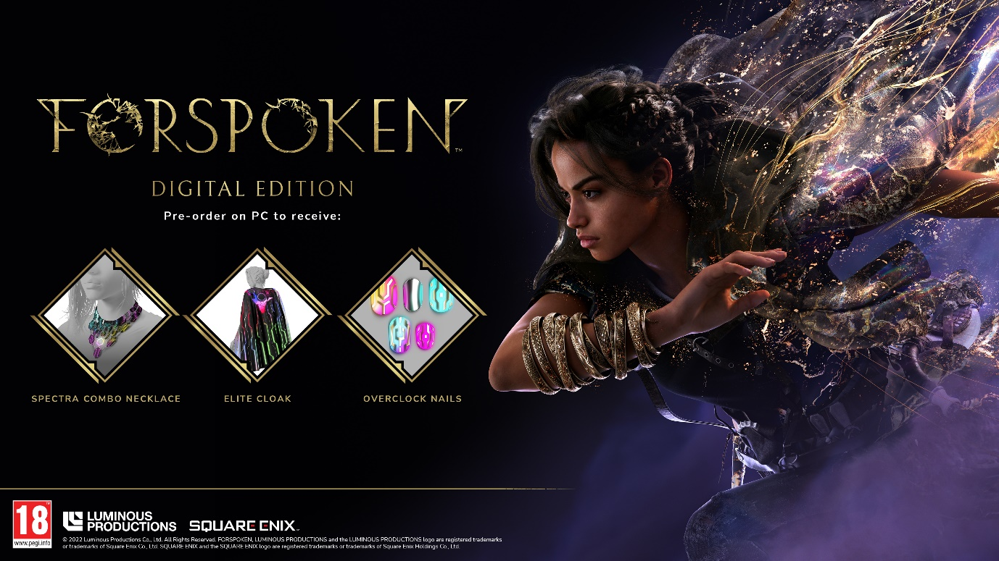

Forspoken will harness the full power of the latest technologies and demonstrate Luminous Productions’ philosophy to provide a gaming experience like never before, fusing together the latest technology with creativity. Forspoken will launch simultaneously on PlayStation® 5 (PS5™) console and the PC (via STEAM®, Microsoft Store, and Epic Games Store) on January 24, 2023.

To learn more about Forspoken, visit: www.forspoken.com.

*only supported during gameplay sequences

Related Links:
Forspoken Website: www.forspoken.com
Luminous Productions Website: https://www.luminous-productions.com
Facebook: www.facebook.com/Forspoken
Twitter: @Forspoken
Instagram: @Forspoken
#Forspoken

About Square Enix Ltd.
Square Enix Ltd. develops, publishes, distributes and licenses SQUARE ENIX® and TAITO® branded entertainment content in Europe and other PAL territories as part of the Square Enix group of companies. The Square Enix group of companies boasts a valuable portfolio of intellectual property including: FINAL FANTASY®, which has sold over 173 million units worldwide; DRAGON QUEST®, which has sold over 85 million units worldwide; and the legendary SPACE INVADERS®. Square Enix Ltd. is a London-based, wholly owned subsidiary of Square Enix Holdings Co., Ltd.

More information on Square Enix Ltd. can be found at https://square-enix-games.com

# # #

©2022 Luminous Productions Co., Ltd. All Rights Reserved
FORSPOKEN, FINAL FANTASY, DRAGON QUEST, LUMINOUS PRODUCTIONS and the LUMINOUS PRODUCTIONS logo SQUARE ENIX, the SQUARE ENIX logo, SPACE INVADERS, and TAITO are registered trademarks or trademarks of the Square Enix group of companies. “STEAM” is a trademark and/or registered trademark of Valve Corporation in the U.S. and/or other countries. “DualSense”, “Dualshock” “PlayStation” and “PS5” are a registered trademark or trademarks of Sony Interactive Entertainment Inc. All other trademarks are properties of their respective owners.

