FOR IMMEDIATE RELEASE

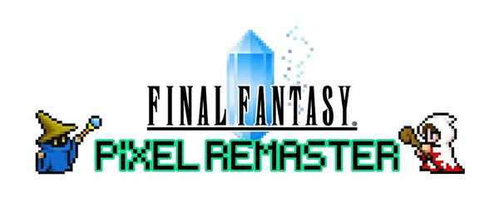
FINAL FANTASY PIXEL REMASTER SERIES LAUNCHING IN SPRING 2023 ON PLAYSTATION4 AND NINTENDO

Physical FINAL FANTASY I-VI PIXEL REMASTER -FF35th Anniversary Edition- Also Revealed with Pre-Orders and Waiting List Now Live

LONDON (Dec. 19, 2022) – SQUARE ENIX® today revealed that the beloved FINAL FANTASY® pixel remaster series, previously only available on Steam® and mobile platforms, is launching on PlayStation®4 (PS4™) and Nintendo Switch™ in Spring 2023. The pixel remaster series brings all the magic of the originals combined with quality-of-life upgrades while staying faithful to the retro design of these masterpieces.

The digital version of all six titles in the FINAL FANTASY pixel remaster series, FINAL FANTASY I through FINAL FANTASY VI, can be purchased individually or as a bundle. Available in limited quantities, the newly announced physical edition of FINAL FANTASY I-VI PIXEL REMASTER -FF35th Anniversary Edition- includes:

- FINAL FANTASY I-VI COLLECTION.
- Anniversary Edition GOODS BOX.
- A bonus lenticular sleeve for the game package.
- A vinyl record set featuring newly arranged game music on 2 records with exclusive cover artwork by Kazuko Shibuya.
- An exclusive artbook showcasing FINAL FANTASY character pixel art.
- Eight stylized pixel art character figures in window packaging.

The FINAL FANTASY I-VI PIXEL REMASTER -FF35th Anniversary Edition- is available exclusively through the Square Enix Store. Join the waiting list here for PlayStation4; Pre-order here for Nintendo Switch.

Players can now join the waiting list for FINAL FANTASY I-VI COLLECTION, a standalone physical edition, available in limited quantities exclusively on the Square Enix Store. Join the waiting list for PlayStation4; Join the waiting list for Nintendo Switch.

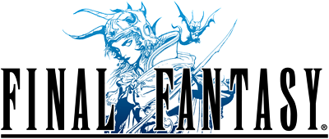
FINAL FANTASY
Earth, fire, water, wind... The light that once shone within the four Crystals was lost. Darkness covered the land, until the only hope for humanity rested in legends past. Become the Warriors of Light and embark on your own journey to restore power to the Crystals and save the world.

Switch between classes to improve your characters. Traverse the wide world with your airship and other vessels. Return to the game that started it all.
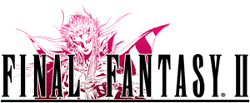
FINAL FANTASY II
Our epic tale begins with four young souls orphaned during the struggle between the Palamecian Empire and the rebel army. On their journey, the youths join forces with the white wizard Minwu, Prince Gordon of Kashuan, Leila the pirate, and many others. Behold the beautiful and sometimes tragic twists of fate that await you on your adventure.

FINAL FANTASY II introduced a unique skill level system that strengthens different attributes of the characters depending on their fighting style instead of leveling up. Use the key terms you learn in conversation to unlock new information and progress in the story.

This innovative game series takes an ambitious turn in this second installment in the FINAL FANTASY series!
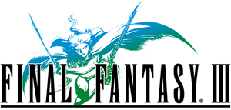
FINAL FANTASY III
With the power of light nearly eclipsed by the power of darkness, only the crystals' four chosen adventurers can save the world.

Experience the iconic job changing system first introduced in Final Fantasy III - switch jobs at will and use various abilities as you progress in the game. Change into a variety of classes like Warrior, Monk, White Mage, Black Mage, Dragoon, Evoker, or even call monsters to do your bidding with as a Summoner.
FINAL FANTASY IV
The story follows Cecil, a dark knight and captain of the Red Wings, who decides to fight against the tyrannical Kingdom of Baron with his trusted friend and his paramour at his side, and later join forces with Kain the dragoon, Rosa the white mage, Rydia the summoner, and many more skilled allies. FINAL FANTASY IV set the standard for role-playing games with its diverse cast of characters, deep plot and real-time Active Time Battle (ATB) system, where time moves even during battle, giving the players an exciting sense of urgency.
FINAL FANTASY V
FINAL FANTASY V presents the story of a young man and his Chocobo, who find themselves drawn toward friends that will change their destiny. When the crystals that balance the powers of the world are threatened, the king hastens to the rescue...only to go missing. Well-regarded for its deep and customizable job system, which allows players to freely select jobs for their characters to master, FINAL FANTASY V supports many different playstyles and expands on the iconic Active Time Battle system, which made its debut in FINAL FANTASY IV.
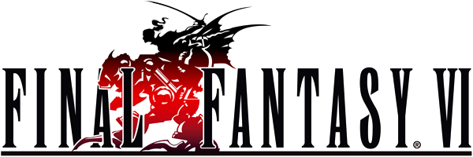
FINAL FANTASY VI
Regarded as one of the most beloved games in the FINAL FANTASY series, FINAL FANTASY VI features a robust roster of playable characters, each with their own stories, goals and destinies. Players will be able to customize their party members’ abilities, magic spells and summons with the acclaimed magicite system.

All six games within the FINAL FANTASY pixel remaster series are currently available for purchase as part of the FINAL FANTASY I-VI Bundle on Steam and are also available for purchase separately on the App Store®, Google Play™ and Amazon App Store.

Visit the official FINAL FANTASY pixel remaster series website for more information at: https://ffpixelremaster.com/

Related Links:
Official Website: https://ffpixelremaster.com/
Facebook: https://www.facebook.com/finalfantasy
YouTube: https://www.youtube.com/finalfantasy
Instagram: @finalfantasy
#FinalFantasy

About FINAL FANTASY
For over 30 years, the FINAL FANTASY series has delighted generations of gamers and millions of players worldwide through beloved Role-Playing adventures that are built upon the benchmarks of spectacular visuals, highly imaginative worlds rich stories, memorable characters and technical and gameplay innovation leading the industry and earning the highest accolades from around the world. Each mainline game in the series is a completely new experience, and an ideal entry point to the series. Titles of the series have sold over 164 million units worldwide.

About Square Enix, Ltd.
Square Enix, Ltd. develops, publishes, distributes and licenses SQUARE ENIX® and TAITO® branded entertainment content in Europe and other PAL territories as part of the Square Enix group of companies. The Square Enix group of companies boasts a valuable portfolio of intellectual property including: FINAL FANTASY®, which has sold over 173 million units worldwide; DRAGON QUEST®, which has sold over 85 million units worldwide; and the legendary SPACE INVADERS®. Square Enix Ltd. is a London-based, wholly owned subsidiary of Square Enix Holdings Co., Ltd.
More information on Square Enix, Ltd. can be found at https://square-enix-games.com

# # #

© 1987, 1988, 1990, 1991, 1992, 1994, 2022 SQUARE ENIX CO., LTD. All Rights Reserved.
LOGO ILLUSTRATION: © 1991, 1992, 1994, 2006, 2007 YOSHITAKA AMANO

FINAL FANTASY, the FINAL FANTASY PIXEL REMASTER logo, DRAGON QUEST, SPACE INVADERS, SQUARE ENIX, the SQUARE ENIX logo and TAITO are registered trademarks or trademarks of the Square Enix group of companies.

