FOR IMMEDIATE RELEASE

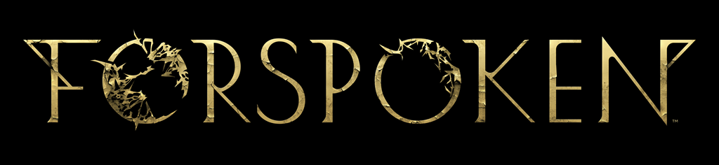

UNCOVER THE MAGIC OF FORSPOKEN WITH
NEW DEEP DIVE VIDEO SERIES

First Video in the Three-Part Series Takes Players on a Journey to
Master Frey’s Magic-Enhanced Parkour Abilities

LONDON (Oct. 27, 2022) – Today Square Enix Ltd., and Luminous Productions kicked off the release of a three-part video series, offering players a deeper look into the gameplay mechanics for their highly anticipated action-RPG, Forspoken. The first video in the series focuses on protagonist Frey Holland’s magic-enhanced parkour and traversal skills, as well as the variety of spells at her disposal giving players a taste of what to expect when the game launches on January 24, 2023.

To watch the Forspoken – Deep Dive | Magic Parkour video, visit: https://www.youtube.com/watch?v=SvPDkdeQikw

The next video in the series, Forspoken – Deep Dive | Magic Combat, releases on November 3, and will dive into the fundamentals of Frey’s magical combat skills. Discover more about the types of magic, attacks and upgrades players can unlock to help Frey battle the wide variety of enemies she’ll encounter throughout her journey. The final video, Forspoken – Deep Dive | Exploring Athia , releases on November 10, and will showcase quests, challenges and various activities that players can find and accomplish across the world of Athia.

Designed for PlayStation®5 (PS5™), Forspoken will harness the full power of the console and demonstrate Luminous Productions’ philosophy to provide a gaming experience like never before, fusing together the latest technology with creativity. Forspoken will launch simultaneously on PS5 and PC (via STEAM®, Epic Games Store or Microsoft Store) on January 24, 2023, and is available to pre-order now. The Forspoken: In Tanta We Trust Story DLC will be available Summer 2023.

To learn more about Forspoken, visit: www.forspoken.com.

Related Links:
Forspoken Website: www.forspoken.com
Luminous Productions Website: https://www.luminous-productions.com
Facebook: www.facebook.com/Forspoken
Twitter: @Forspoken
Instagram: @Forspoken
#Forspoken

About Square Enix Ltd.
Square Enix Ltd. develops, publishes, distributes and licenses SQUARE ENIX® and TAITO® branded entertainment content in Europe and other PAL territories as part of the Square Enix group of companies. The Square Enix group of companies boasts a valuable portfolio of intellectual property including: FINAL FANTASY®, which has sold over 173 million units worldwide; DRAGON QUEST®, which has sold over 85 million units worldwide; and the legendary SPACE INVADERS®. Square Enix Ltd. is a London-based, wholly owned subsidiary of Square Enix Holdings Co., Ltd.

More information on Square Enix Ltd. can be found at https://square-enix-games.com

# # #

©2022 Luminous Productions Co., Ltd. All Rights Reserved
FORSPOKEN, FINAL FANTASY, DRAGON QUEST, SQUARE ENIX, the SQUARE ENIX logo, SPACE INVADERS, and TAITO are registered trademarks or trademarks of the Square Enix group of companies. “PlayStation” and “PS5” are a registered trademark or trademarks of Sony Interactive Entertainment Inc. All other trademarks are properties of their respective owners.

