**FOR IMMEDIATE RELEASE**

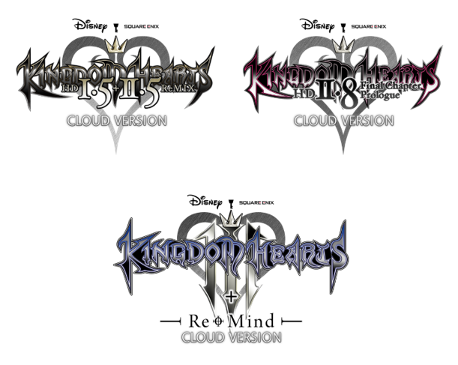

**BELOVED KINGDOM HEARTS TITLES COMING TO NINTENDO SWITCH VIA CLOUD ON FEBRUARY 10**

*Pre-Orders Open and Free Demos Available to Download Today*

**LONDON (Jan. 18, 2022)** **–** To kick off celebrations for the 20th anniversary of KINGDOM HEARTS, SQUARE ENIX Ltd. and Disney today announced that fans can now pre-order four beloved KINGDOM HEARTS titles coming to Nintendo Switch™ via cloud on February 10. Cloud versions include *KINGDOM HEARTS HD 1.5 + 2.5 ReMIX*, *KINGDOM HEARTS HD 2.8 Final Chapter Prologue*, *KINGDOM HEARTS III + Re Mind (DLC)* and the all-in-one *KINGDOM HEARTS series collection for Cloud*. By purchasing *KINGDOM HEARTS III + Re Mind (DLC)*, either as a standalone title or through the all-in-one collection, players will receive the Advent Red Keyblade for use in that game.

Watch the new KINGDOM HEARTS Series for Nintendo Switch Cloud Version Trailer trailer here: <https://youtu.be/J0CQp7npkeQ>



For a full list of games included in each collection, visit: <https://square-enix-games.com/en_GB/news/kingdom-hearts-switch>

Free playable demos are now available for three of the beloved KINGDOM HEARTS titles, including *KINGDOM HEARTS HD 1.5 + 2.5 ReMIX*, *KINGDOM HEARTS HD 2.8 Final Chapter Prologue* and *KINGDOM HEARTS III + Re Mind (DLC)*, enabling players to test out their connections prior to purchasing.

For updates on the KINGDOM HEARTS 20th Anniversary events, follow us on Facebook: [@KingdomHearts](https://www.facebook.com/KingdomHearts/).

The first entry in the KINGDOM HEARTS franchise was first released twenty years ago in 2002, thus launching the longstanding collaboration between SQUARE ENIX and Disney. Since then, over 35 million copies have shipped worldwide. Nintendo Switch players, who have eagerly awaited the arrival of the series’ back catalogue on the platform, will soon be able to join Sora, Donald, Goofy, and many other Disney and Pixar characters on adventures through the “Dark Seeker Saga,” spanning from the original *KINGDOM HEARTS* to the critically acclaimed *KINGDOM HEARTS III + Re Mind (DLC)*.

To pre-order these titles, please visit the page here: <http://www.kingdomhearts.com/switch>

The KINGDOM HEARTS series cloud version games will be available on Nintendo Switch in selected regions* on February 10 and are rated PEGI 12. For more information, visit: <https://square-enix-games.com/en_GB/news/kingdom-hearts-switch>

For the latest assets, visit: <https://press.uk.square-enix.com/>

**Related Links:**

**Official KINGDOM HEARTS Website:** [www.kingdomhearts.com](http://www.kingdomhearts.com/)

**Official KINGDOM HEARTS Twitter:** [@KingdomHearts](https://twitter.com/kingdomhearts)

**Official KINGDOM HEARTS Facebook:** [@KingdomHearts](https://www.facebook.com/KingdomHearts/)

**Official KINGDOM HEARTS YouTube:** [www.youtube.com/KingdomHearts](http://www.youtube.com/KingdomHearts)

**Official KINGDOM HEARTS Instagram:** [@KingdomHearts](https://www.instagram.com/kingdomhearts/)

#KingdomHearts

*The KINGDOM HEARTS series cloud version games will be available in the following territories: Japan, US and Canada, Austria, Belgium, Bulgaria, Croatia, Czech Republic, Denmark, Estonia, Finland, France, Germany, Greece, Hungary, Ireland, Italy, Latvia, Lithuania, Luxembourg, Netherlands, Norway, Poland, Portugal, Romania, Slovakia, Slovenia, Spain, Sweden, Switzerland, United Kingdom, Korea and Hong Kong.

***About the KINGDOM HEARTS Series***

KINGDOM HEARTS is a series of role-playing games created through the collaboration of Disney and Square Enix. Since the first *KINGDOM HEARTS* was released in March 2002 for the PlayStation®2 computer entertainment system, the series has expanded with several additional entries. The series will celebrate its 20th anniversary in 2022 and has shipped over 35 million units worldwide. Since the launch of *KINGDOM HEARTS III* in 2019, the critically acclaimed RPG has shipped more than five million units globally, both physically and digitally, making it the fastest selling game in the history of the series. Most recently in 2020, the rhythm-action adventure *KINGDOM HEARTS* *Melody of Memory* released on Nintendo Switch, PlayStation®4 system, Xbox One family of devices, including Xbox One X, and PC via the Epic Games Store, allowing fans to experience the series’ beautiful soundtracks like never before.

***About Square Enix Ltd.***

Square Enix Ltd. develops, publishes, distributes and licenses SQUARE ENIX®, EIDOS® and TAITO® branded entertainment content in Europe and other PAL territories as part of the Square Enix group of companies. Square Enix Ltd. also has a global network of leading development studios such as Crystal Dynamics® and Eidos Montréal®. The Square Enix group of companies boasts a valuable portfolio of intellectual property including: FINAL FANTASY, which has sold over 163 million units worldwide; DRAGON QUEST®, which has sold over 83 million units worldwide; TOMB RAIDER®, which has sold over 84 million units worldwide; and the legendary SPACE INVADERS®. Square Enix Ltd. is a London-based, wholly owned subsidiary of Square Enix Holdings Co., Ltd.

More information on Square Enix Ltd. can be found at <https://square-enix-games.com>.

# # #

© Disney. © Disney/Pixar.

Developed by SQUARE ENIX.

CRYSTAL DYNAMICS, DRAGON QUEST, EIDOS, EIDOS MONTREAL, FINAL FANTASY, SPACE INVADERS, SQUARE ENIX, the SQUARE ENIX logo, TAITO and TOMB RAIDER are registered trademarks or trademarks of the Square Enix group of companies. Nintendo Switch is a trademark of Nintendo. All other trademarks are properties of their respective owners.